From Heartbreak
to Hope…

COPING WITH LIFE ALONE


 Date: September 22nd - November 24th $25 (includes
 Time: 7:00 - 8:30 p.m. Workbook)
- Location: Either on Zoom or at St. Joseph's Church: 717 N. Bradford Placentia, CA 92870
Contact: Carol Koppenheffer 714 528-1487 Ext 221

For the Divorced, Separated, and Widowed

A program for men and women experiencing a spousal loss through death, separation, or divorce, to begin healing and focus on moving forward.

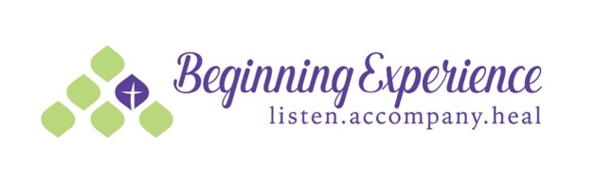
A program developed by Beginning Experience International

Ministry

