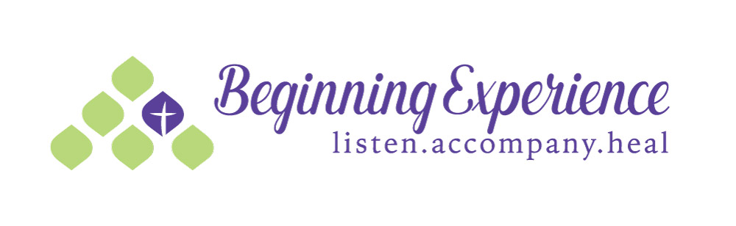

Offering hope to those grieving the loss of a marriage

Beginning Experience of Orange County is sponsoring a

HEALING
WEEKEND!

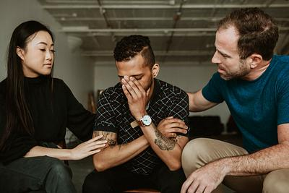

FOR
MEN
AND
WOMEN
WHO ARE SEPARATED, DIVORCED,
OR
WIDOWED

 Date From/To: October 9th – 11th
 Location Address: Pro-Sanctity Center in Fullerton
 BE Contact Person: Kim Dodson
 Phone # 714 336-3221
 BE Email Address: BEOC2015@gmail.com

Pre-Registration is Required

