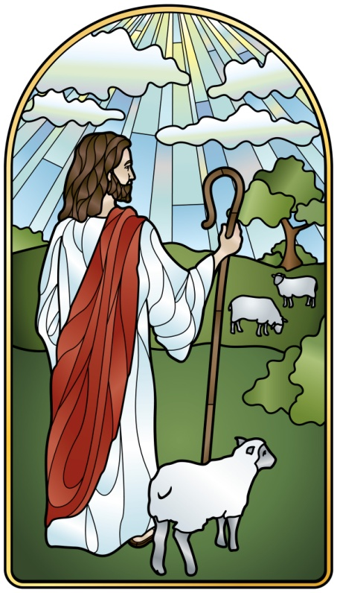
Welcome Home,
Returning Catholics!
Are you a Catholic who has felt separated from the Church?
Do you desire a renewed relationship with God and the Church?
St. Joseph’s Welcome Home ministry is here to assist you!
7 sessions…
…to get answers to your questions
…to get an update of the Catholic faith
…to feel at home once more in the Catholic Church
Reunite
Seek
Understand

Join us • Thursdays, 7 - 9 pm • Parish Center rm. 3&4
Oct. 5 Welcome; Overview & Sharing Our Stories
Oct. 12 God’s Mercy and the Sacrament of Reconciliation
Oct. 19 The Church Today & Overview of the Sacraments
Oct. 26 Explanation of the Mass & The Creed
Nov. 2 Prayer & Catholic Devotions; Intro to the Bible
Nov. 9 Behind-the-Scenes Tour of St. Joseph Church
Nov. 16 How to Keep Growing in Faith
Invite your friends and family!
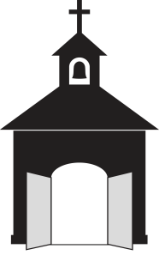
Call or e-mail for more information:
St. Joseph Catholic Church 714-528-1487 x221
Carol Koppenheffer@stjosephplacentia.org

