Parish Bulletin Announcements/Notes Samples
for Mental Health Awareness Month (May)

May 1, 2022
Mental Health Ministry: CA Bishops’ Pastoral Letter

Every month should be a month we are paying attention to our mental health, right? But with May as Mental Health Matters Month, we have a special focus on getting the word out about what you can do to take action for your mental health and for others!
In 2018, the Bishops of California released a pastoral letter on mental health called Hope and Healing. The first principle of that letter is that God calls us to attend to those who suffer from mental illness and provide hope and healing.
There is hope for those of us with mental illness. Recovery is possible and the church plays an important role. The role of the church is to give people back their names, and to remind one another that we are beloved children of God.
Curious to learn more? Read the pastoral letter here: https://www.cacatholic.org/article/hope-and-healing
Our diocese cares about mental health. For mental health resources and support, or to join the ministry, visit https://catholicmhm.org/orange.
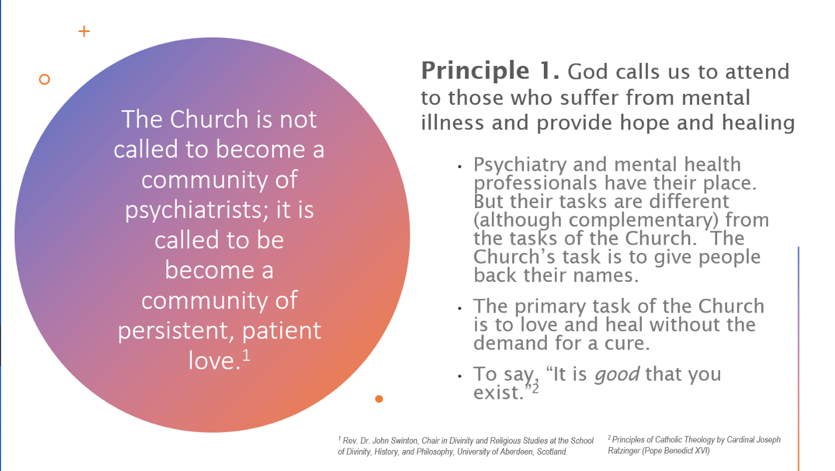
If you would rather have a graphic instead of a little article, use this one:

May 8, 2022
Mental Health Ministry: St. Dymphna

Did you know there are Saints we can pray through for mental illness? Learn about and celebrate St. Dymphna, the patron saint of mental illness. Her feast day is May 15th! St. John of God is another! His feast day is March 8th. Learn more at Association of Catholic Mental Health Ministers (catholicmhm.org). To find out more about saints, go to the worship and liturgy resource page and scroll down to information about saints.

Our diocese cares about mental health. For mental health resources and support, or to join the ministry, visit https://catholicmhm.org/orange.

May 15, 2022
Let’s Take Action for Mental Health.
You may already know that more than half of all Americans will experience a mental illness or disorder in their lifetime. And just about all of us have times when we feel stressed out, anxious, or down. When that happens to you or a loved one, do you know what to do?
Recognizing that you or someone you know could use some support for your mental health is the first step. That means checking in with yourself regularly, and checking in with others to see if they may need help. Then you can take action to get support if it’s needed.
Join us and people across California in taking the Take Action for Mental Health Pledge. This is a way to commit to ourselves and the people around us that mental health is a priority and that we will do what we can to support each other.
The Take Action for Mental Health Pledge says:
I Pledge to Take Action for Mental Health
- I will Check In with myself to identify mental health needs.
- I will Learn More about mental health.
- I will Get Support for my own mental health and support the mental health of others.
- I will share this pledge with others to help them take action too!
To learn more about taking action for your mental health and the mental health of your loved ones, see the Take Action for Mental Health website: https://takeaction4mh.com/
Our diocese cares about mental health. For local mental health resources and support, or to join the ministry, visit https://catholicmhm.org/orange.

May 22, 2022
New Hope Crisis Counseling 714-NEW-HOPE

Did you know about our New Hope Crisis Counseling Center at Christ Cathedral? It was established in 1968 after a death by suicide in Dr. Schuller’s congregation. Catholic Charities took over when it became Christ Cathedral. This is a general hotline for any reason, even to aid loneliness. The main purpose, however, is suicide prevention and intervention. New Hope is staffed by volunteers and college interns as a faith-based hotline. The volunteers are not counselors, but are trained in the Active Listening model. They have had many more calls since COVID. They’d love more volunteers, who typically work once a week in a 4 hour shift. New Hope provides referrals for those in need (about 1 in 11 clients). They work closely with 211OC, and try to open the door to on-going therapy. They also offer prayer to all their callers. Contact the director, Louise Dunn at 714-New-Hope or ldunn@ccoc.org for more information.

Our diocese cares about mental health. For local mental health resources and support, or to join the ministry, visit https://catholicmhm.org/orange.

May 29, 2022
Sanctuary Mental Health for Catholics

One in four people will be affected by a mental health problem this year, yet the stigma surrounding mental illness silences many and prevents faith communities from responding compassionately and effectively. This eight-session course explores the realities of mental health and illness, as well as the vital need for faith-based community conversations about these topics. The sessions are accompanied by compelling films that feature the stories of Catholics living with mental health challenges, along with the insights of archbishops, theologians, and psychologists. You can access the course free of charge here: https://www.sanctuarymentalhealth.org/catholics/

Our diocese cares about mental health. For mental health resources and support, or to join the ministry, visit https://catholicmhm.org/orange.

